**Invitation-cum-Selection Letter**

Dear Sir/Madam,

Greetings from Techfest, IIT Bombay!

Techfest is the annual science and technology festival of IIT Bombay, one of the most prestigious educational institutes in India. Since its inception in 1998, Techfest has provided a common thinking ground to students for new ideas, creativity and innovation. Techfest is not only a technical festival but a unique amalgamation of competitions, exhilarating exhibitions, lectures from eminent personalities, workshops to provide hands-on valuable experience to students, cultural shows to showcase unique skill-sets from all over the world and our social initiatives aimed to reform present-day India.

This edition of Techfest is scheduled to be held from 3rd to 5th January 2020. The following people (Team ID: WCZ- 69894744) have been selected in finale of Cozmo Clench to be held during Techfest 2019-20.

1) Abu M Fuad (ID no: 18.01.05.146)

2) Md Khairul Islam (ID no: 116)

3) Abu Saleh Md. Boni Momin (ID no: 011 193 076)

On behalf of Techfest team, I would like to invite them to IIT Bombay, Mumbai for competing in Cozmo Clench. It will be much appreciated if you can assist them in applying for the necessary entry visa to India. Thank you in advance for your kind attention.

With warm regards,

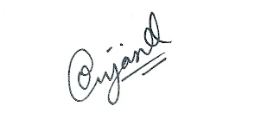

Om Jaiswal

Competitions Manager, Techfest 2019-20

IIT Bombay

[omjaiswal@techfest.org](mailto:omjaiswal@techfest.org)

+91-74004 00933